Improvements to registration page:

Originally, the design of the registration page was done by hand, and it looked as such:

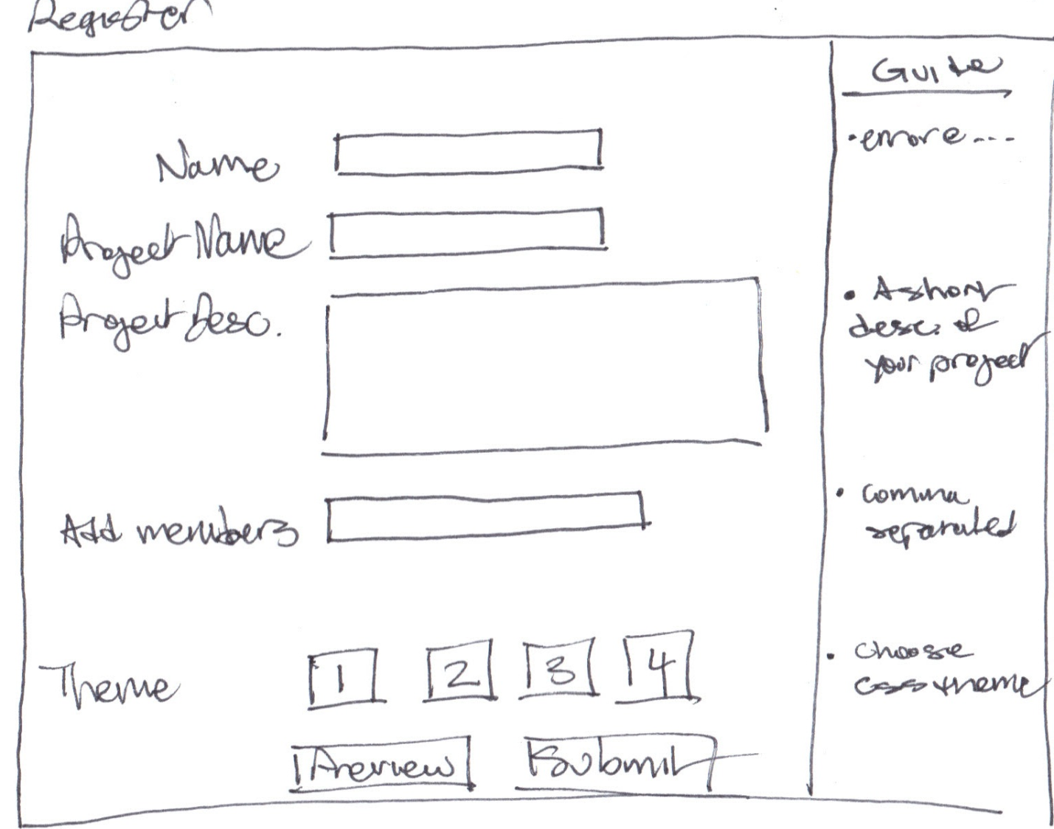Figure: original sketch of register web page

Then, as a hand drawn sketch was deemed unacceptable, a similar mockup was done in paint:

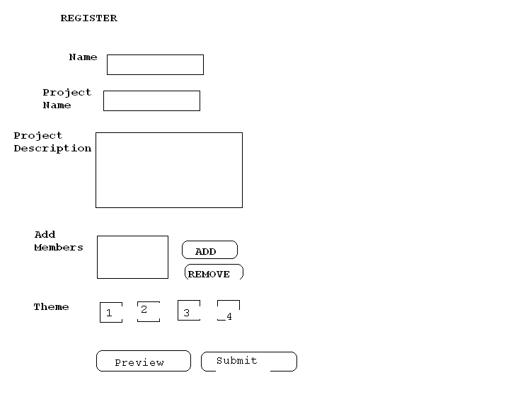M.S Paint mockup of registration page

No new features were implemented, this is a rough sketch of what the finished product will look like.

Originally, the web page only had the bare minimum fields required for user registration. The page looked like the following:

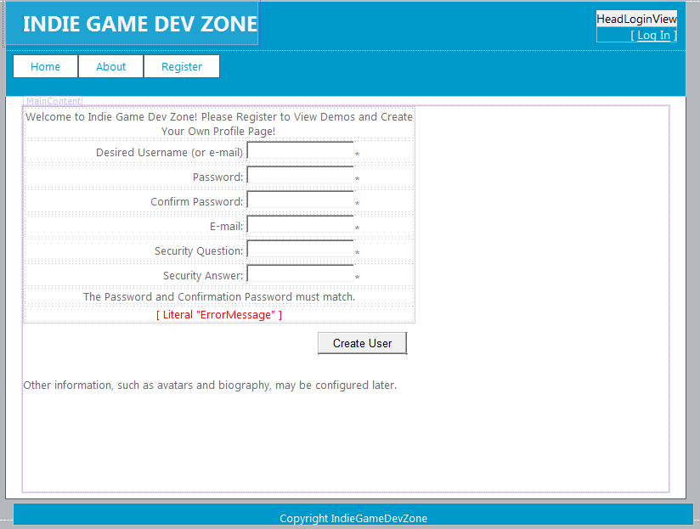

Figure: First iteration of web page in Visual Studio 2010.

Which is ok if we want the bare minimum, but there are other fields the user could enter that would be very useful during registration. Thus, a new web page to reflect this, was made. Some of the changes include changed format, wording, and new fields that would facilitate profile creation, avoiding unnecessary edits in the future. The new, revamped register page looks like the following:

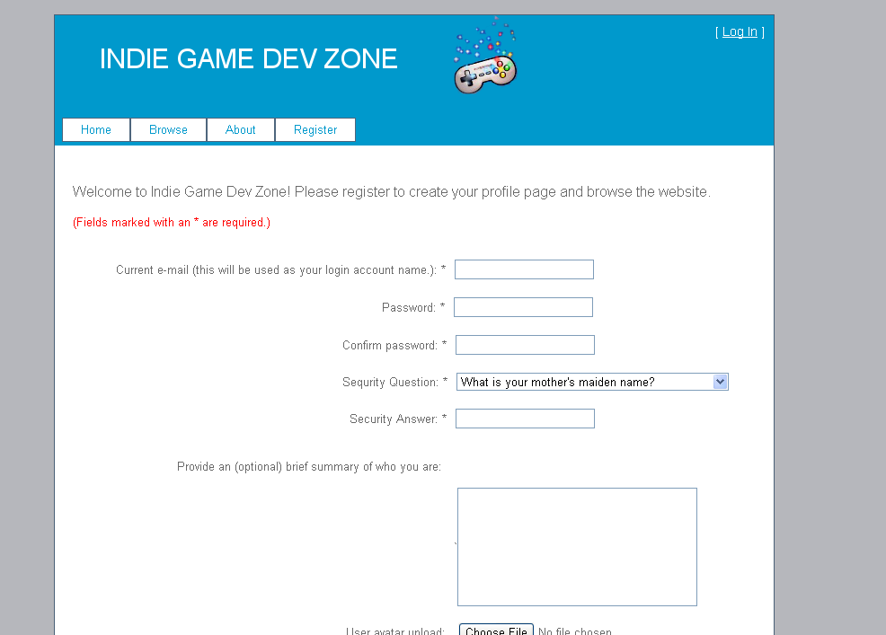



Figure: revamped webpage, upper snf loert hslgd

Features are pretty straightforward on this page: the text boxes work like text boxes, the image upload buttons browse your computer and allow you to select images for upload, and the submit button sends all this data to the server, makes sure there are no errors, and creates a new user into the database if the user does not exist. There is a text literal that will pop any errors that the server detects in the fields.